The Centre for Applied Genomics (TCAG)
Extractions Facility

New Study Form

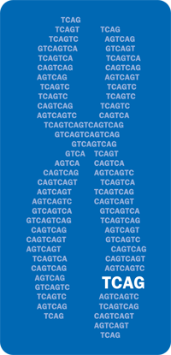 | THE HOSPITAL FOR SICK CHILDREN  The Centre for Applied Genomics (TCAG)  Peter Gilgan Centre for Research and Learning (PGCRL)  686 Bay St., Room 13.9400  Toronto, Ontario  Canada, M5G 0A4 |  |  |  |  |  |  |  |  |  |  |  |  | Lab Contact: Miranda Lorenti  E-mail: miranda.lorenti@sickkids.ca  Web: tcag.ca/facilities/biobanking
Study / Project Name:
Referring Scientist:
Address:
Contact Name: |  |  |  |  |  |  |  |  |  |  |  |  |  |  | Tel: |  |  | ( ) - |  |  |  | ext:
Contact Email:
Cost Centre: (if Internal)
Duration of Study: |  |  | Start: |  |  |  |  |  |  |  |  |  |  |  | End:
Anticipated No. Samples/Year: |  |  |  |  |  |  |  |  |  | (Specimen Type 1 |  |  |  |  |  |  |  |  |  |  |  |  |  | )
Anticipated No. Samples/Year: |  |  |  |  |  |  |  |  |  | (Specimen Type 2 |  |  |  |  |  |  |  |  |  |  |  |  |  | )
Service requested: |  |  |  | DNA Extraction |  |  |  |  |  |  |  |  | RNA Banking
 |  |  |  | RNA Extraction |  |  |  |  |  |  |  |  | Aliquoting
 |  |  |  | DNA Banking |  |  |  |  |  |  |  |  | Other:
Specimen type: |  |  |  | Blood: |  |  | Fresh |  | Saliva: |  | Oragene |  |  |  | DNA |  |  |  | Cell Pellet
 |  |  |  |  |  |  | Frozen |  |  |  | Sponges |  |  |  | RNA |  |  |  | Other
DNA/RNA Pick Up: |  |  |  | Monthly |  |  |  |  |  |  |  | Quarterly |  |  |  |  |  |  |  | End of study
Additional Notes:
Biobanking Form: 002
Revision date: January 2025

